CHRISTMAS BIRD COUNT
MONDAY, December 17, 2018
7:30 - dusk (or as long as you can hang on!!)
You can either bird in the field or at your feeder.
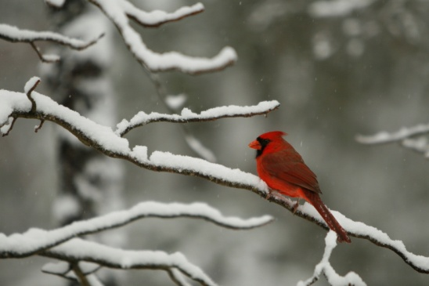
Sign up at the Audubon meeting OR on our website at hsvbirds.org
Deadline for sign up: Thursday, December 13 for both count and dinner
CHRISTMAS BIRD COUNT DINNER
Tuesday, December 18, 2018 at 5pm at The DeSoto Club
MENU:
Green salad, green beans, rice pilaf, cheesecake bites for dessert, AND
YOUR ENTREE CHOICE OF ONE OF THE FOLLOWING:
1)Parmesan Crusted Chicken 2) Grilled Pork Chop with Dried Cherry and Apple Chutney
3) Braised Beef Tips

Cost is $20 which includes tax and tip.
Make check payable to: HSV Audubon
Give your check or cash to Chris Cash or Carolyn Minson at an Audubon meeting or
mail to Chris at 10 Caribe Way, HSV 71909

Pay-as-you-go Bar

